**User Story**

Written Report

**Team 2**

Team Member:

Bhavsar, Dhruvit Vibhakar – Financial Advisor

Koshti, Khushboo – Premium User

Lamichhane, Nishan - Administrator

Liu, Ziyan – Regular User

Virk, Ranvir – Data Analyst

COMP231(Sec.007)

October 28, 2023

Professor : llir Dema

Centennial College

Regular User:

Low-fidelity prototype:

|  |  |
| --- | --- |
| ------------------------------------------------------------------  **Add New Spending:** As a regular user, I want to manually add new transactions. This allows me to record cash spendings or earnings and include them in the monthly transaction tally.  Note: Ensure options for categorizing the transaction | **Home Page**: As a regular user, I want to load my home page to check my current balance and monthly spending. This helps me understand how much I've spent so far and aids in making informed decisions for better money management.  Note: The monthly spending section can be enlarged.  ----------------------------------------------------------------  **Detailed Monthly Transaction**: As a regular user, I want to view my spending by category for the current month. This gives me insight into which items I've spent the most on.    Note: Two display options can be provided: monthly or yearly.  Note: Use pie charts or bar charts for visualization.  ----------------------------------------------------------------  **Detailed Category Transaction**: As a regular user, I want to view transactions for a specific category to determine the highest expenses within that category.  Note: Rank item prices from high to low. |

Story Card:

|  |  |
| --- | --- |
| A user can view their main app page  Note: Ensure quick access to key features.  Estimate: 1 hr. | Test with a returning user.  *Expected outcome*: User sees main features instantly. |
| Users can see their monthly spending.  Note: Do we need a filter option for date ranges?  Note for UI: Clear breakdown of expenses.  Estimate: 3 hrs. | Test with a user with a month's worth of data.  *Expected outcome:* User understands monthly spendings.  Test with a long-term user (more than a year).  *Expected outcome*: The user should be able to scroll through and see all transactions for the selected month. |
| Users can view spending by category.    Note: Shows specific items.  Estimate: 2 hrs. | Test with a user.  *Expected outcome*: The user should be able to select a category and see all related transactions. |
| Users can input a new transaction.    Note for UI: Simple entry form.  Estimate: 3.5 hrs. | Test with a new user adding their first transaction.  *Expected outcome:* The user should be guided through the process without confusion, and the new transaction should reflect immediately. |

Premium User:

Low-fidelity prototype:

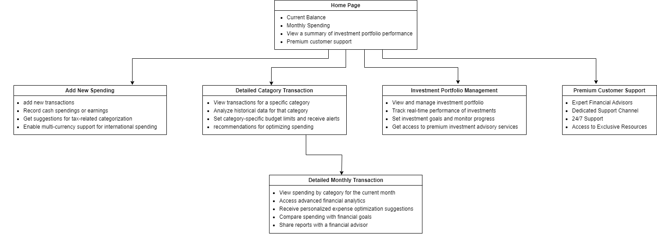

|  |  |
| --- | --- |
| **Add New Spending:** As a premium user, I want to manually add new transactions such as cash revenues or expenditures. As a premium user I am able to easily manage my transactions in several currencies.  Note: Ensure options for categorizing the transaction  Note: Consider adding a filter option for date ranges.  ------------------------------------------------------------------  **Investment Portfolio Management:** As a premium user, I want to have a thorough review of my financial portfolio. It will make things simple for me to handle all of my assets, investment types, and related information in one location.  Note: Assist them for personalized recommendations for optimizing their investments  ------------------------------------------------------------------  **Premium Customer Support:** As a premium user, I can speak with experts in finance who are knowledgeable about the ins and outs of investing and money management. Also, Expert customer service is accessible 24/7, offering help anytime it's needed.  Note: Ensure to give high level of priority to premium users | **Home Page**: As a premium user, I want to load my home page to check an overview of the performance of their portfolio. In addition to viewing past performance statistics and receiving tips for improving the investment strategy, I want to keep an eye on the current value of their assets.  Note: The monthly spending section can be enlarged.  ----------------------------------------------------------------  **Detailed Monthly Transaction**: As a premium user, I want to view Advanced financial metrics and trends relevant to the present month. This gives me a better knowledge of my financial health, I can view charts, graphs, and comprehensive reports that showcase my monetary behavior and accomplishments.    Note: Two display options can be provided: monthly or yearly.  Note: Use pie charts or bar charts for visualization.  ----------------------------------------------------------------  **Detailed Category Transaction**: As a premium user, I want to view all transactions associated with a certain spending category, such as food, entertainment, or utilities. This will help me to evaluate the evolution of the expenditures in this area, compare monthly or annual trends, and examine the way I spend over time.  Note: Rank item prices from high to low. |

Story Card:

|  |  |
| --- | --- |
| A premium user wants to access and interact with advanced financial management features from my main app page.  Note: Make sure that the design is simplified to allow for easy accessibility to sophisticated capabilities.  Estimate: 1.5 hr. | Test with a returning premium user.  *Expected outcome*: I can easily locate and access advanced financial tools and features from the main page. |
| Premium Users can see their monthly spending monthly spending, including categories, trends, and recommendations for optimization.  Note: Does the feature include advanced AI-driven spending recommendations?  Estimate: 3.5 hrs. | Test with a premium user with extensive spending data.  *Expected outcome:* I gain deep insights into my monthly spending patterns and receive advanced recommendations for optimization.  Test with a long-term user (more than a year).  *Expected outcome*: The user should be able to scroll through and see all transactions for the selected month and also can get advance recommendations for optimization. |
| Premium Users can establish specific financial goals, track their progress, and receive recommendations tailored to the premium user profile.    Note: Are these goals linked to investment strategies?  Estimate: 3 hrs. | Test with a premium user setting financial goals.  *Expected outcome*: I can effectively set, monitor, and adjust my financial goals with personalized recommendations. |
| Premium Users can access a comprehensive view of their investments, monitor their real-time performance, and receive personalized investment recommendations for portfolio optimization.    Note: Does this include real-time alerts for significant changes in investment values?  Estimate: 4.5 hrs. | Test with a premium user managing their investment portfolio.  *Expected outcome:* I can efficiently manage my investments, receive recommendations for optimization, and stay informed about any significant changes in portfolio values. |

Administrator

Low-fidelity prototype:

|  |  |
| --- | --- |
| ------------------------------------------------------------------  **Reporting and Analytics**: As an Administrator, I need access to reports and analytics related to system usage and user activity. This helps in monitoring system performance and user engagement.  Estimate: 6 hrs.  Test with generating system usage reports.  Expected outcome: The Administrator should be able to generate and view reports on various aspects of the system, such as user activity and system performance. | **User Management**: As an Administrator, I want to be able to manage user accounts. This includes the ability to create new user accounts, deactivate or suspend accounts, and reset user passwords.  Estimate: 4 hrs.  Test with a user account creation.  Expected outcome: The Administrator should be able to create a new user account with the necessary user details.  ----------------------------------------------------------------  **Access Control**: As an Administrator, I need to have control over the access levels of other users. I should be able to grant or restrict access to specific features and functionalities based on user roles.  Estimate: 3.5 hrs.  Test with a user access restriction.  Expected outcome: The Administrator should be able to restrict access for a user and verify that the user's access has been modified accordingly.  ----------------------------------------------------------------  **User Data Backup**: As an Administrator, I want to be able to back up user data periodically. This will ensure that user data is safe and can be restored in case of system failures or data loss.  Estimate: 5 hrs.  Test with a data restoration process. Expected outcome: The Administrator should be able to successfully back up and restore user data. |

Story Card:

|  |  |
| --- | --- |
| Acceptance Criteria 1 - The Administrator can access the user role management section from the executive dashboard. | TEST  Access the software as the Administrator.  Navigate to the administrative dashboard.  Look for and click on on the "User Role Management" phase.  Ensure that the User Role Management section is offered with out mistakes or access restrictions. |
| Acceptance Criteria 2 - The Administrator can view a listing of all registered customers and their current roles. | Test:    Access the User Role Management segment because the Administrator.  Verify that a listing of all registered customers is displayed.  For every person inside the list, take a look at that their modern-day function is really displayed next to their username.  Ensure that the list is accurate and updated. |
| Acceptance Criteria 3 - The Administrator can choose a user and exchange their role to an available role from a predefined listing. | TEST  Access the User Role Management section as the Administrator.  Choose a specific consumer from the listing.  Locate the option to exchange the consumer's position.  Select a position from the predefined listing (e.G., ordinary user to top class person).  Confirm the role alternate action.  Verify that the user's position has been efficaciously up to date. |
| Acceptance Criteria 4 - When a person's position is modified, the person ought to acquire a notification approximately the role alternate. | TEST  Access the software because the Administrator.  Change the role of a selected user.  Access the user's account because the affected person.  Verify that the user has obtained a notification about the role change.  Ensure the notification truly states the exchange within the consumer's role. |

Financial Advisor:

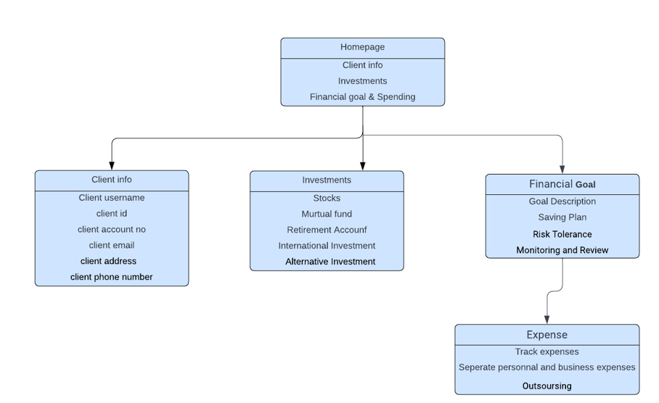

|  |  |
| --- | --- |
| A user can view their home page of application    Expected :1 hour | Test with a returning user .  Expected outcome : Users can sees the navigation bar with three main options . |
| User can see his profile .    Note :Show specific items  Expected :1 hour | Test with user .  Expected outcome: User can see his profile , like username , id, account no, phone no and email. |
| User can view the investment page      Expected :2 hour | Test with user .  Expected outcomes :user can view where he/ she made an investments like in stokes ,mutual fund , foreign investments and other investments. |
| User can view Financial goal              Expected :3 hour | Tested with a user    Expected User : The users should easily guided with new short term and long term goals .in addition saving plan for their next generation and even on the daily uses. It also helps them to monitoring and review their previous month finance like their spending and they also gets a specialist who can guide them . |
| User can view their expenses            Note : it shows their past record also.  Expected : 2 hour | Test with user .  Expected outcome : The user can easily figure out about their expenses like in both in their personal and business . it also shows the outsourcing .    Test with a new user .  Expected outcome :New user can easily understand about their current moth and previous month expense and also get some guidance where a user can save their money. |

Data Analyst:

**USER STORY CARDS**

**1. User Story:** **Customizable Financial Metrics Dashboard**

   - As a Data Analyst, I require a highly customizable dashboard to prioritize and monitor specific financial metrics that align with our data analysis objectives.

   - Estimate: 2 hrs.

   - Test with an experienced Data Analyst.

   - Expected outcome: I can personalize the dashboard to display and track key financial indicators relevant to our analysis goals, ensuring quick access to critical data points.

**2. User Story: Scheduled Recurring Data Imports**

   - As a Data Analyst, I need the ability to schedule and automate recurring data imports from diverse sources, including bank accounts and financial apps.

   - Estimate: 4 hrs.

   - Test with a Data Analyst configuring automated imports.

   - Expected outcome: I can set up automated data imports at specified intervals, ensuring a continuous flow of fresh financial data for analysis.

**3. User Story: Data Cleansing and Normalization Tool**

   - As a Data Analyst, I rely on a comprehensive data cleansing and normalization tool to maintain data accuracy and consistency throughout the analysis process.

   - Estimate: 3 hrs.

   - Test with a Data Analyst cleaning and normalizing data.

   - Expected outcome: I can utilize a data tool to cleanse and normalize financial data, enhancing its quality and consistency for accurate analysis.

**4. User Story: Custom Financial Report Generation and Sharing**

   - As a Data Analyst, I aim to create and share custom financial reports with colleagues and clients to communicate our findings effectively.

   - Estimate: 5 hrs.

   - Test with a Data Analyst generating and sharing reports.

   - Expected outcome: I can effortlessly generate tailored financial reports and seamlessly share them with stakeholders, facilitating clear communication of financial insights.

**5. User Story: Advanced Data Modeling and Statistical Analysis**

   - As a Data Analyst, I need access to advanced data modeling and statistical analysis capabilities for conducting in-depth financial analysis.

   - Estimate: 6 hrs.

   - Test with an experienced Data Analyst conducting advanced analysis.

   - Expected outcome: I can apply advanced data modeling and statistical techniques to derive profound insights from financial data, supporting comprehensive analysis.

**6. User Story: Collaborative Data Sharing with Team**

   - As a Data Analyst, I seek the capability to collaborate with other data professionals by sharing datasets and analysis scripts, fostering collective data analysis efforts.

   - Estimate: 3 hrs.

   - Test with a team of Data Analysts.

   - Expected outcome: I can seamlessly share datasets and analysis scripts with team members, encouraging collaborative data analysis and knowledge exchange.

**7. User Story: Automated Alerts and Notifications**

   - As a Data Analyst, I require the functionality to configure automated alerts and notifications for specific financial events or thresholds.

   - Estimate: 4 hrs.

   - Test with a Data Analyst configuring alerts.

   - Expected outcome: I can set up automated alerts and notifications for crucial financial events, ensuring prompt responses to critical developments